Any full-time faculty member that is teaching over 15 credit hours per semester will receive overload compensation. Please complete the information below and return to the Associate Dean for Academic Affairs, for verification and signature prior to 3 weeks after the start of each semester. This form will be forwarded to the Campus Dean for final approval. Overload payments will be distributed during the first pay period in May and/or December depending on term.
Faculty Overload
Agreement Form

Submitted by: ___________________________________________ Date: ___________ Semester: ________________

Regular course load:
Course prefix/number | Course title | Number of credits

Identify course(s) of overload:
Course prefix/number | Course title | Number of credits

Calculated payment: Number of credits of overload x rate of pay per credit (as determined by the overload pay schedule) = total of payment
Enter number of credits of overload. X $Enter rate/credit. = $Enter total of payment.

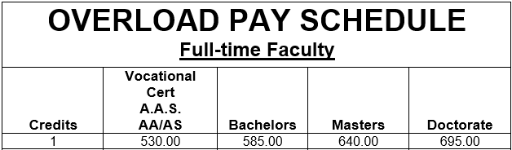

Approvals
 | Associate Dean for Academic Affairs |  | Date
 | Campus Dean |  | Date

